[gardenia.net](https://www.gardenia.net/plant-variety/prunus-yedoensis-yoshino-cherry-tree)

**Prunus x yedoensis (Yoshino Cherry Tree)**

5-7 minutes

***Yoshino Cherry Tree, Japanese Flowering Cherry, Yoshino Cherry, Potomac Cherry, Tokyo Cherry (Prunus x yedoensis)***

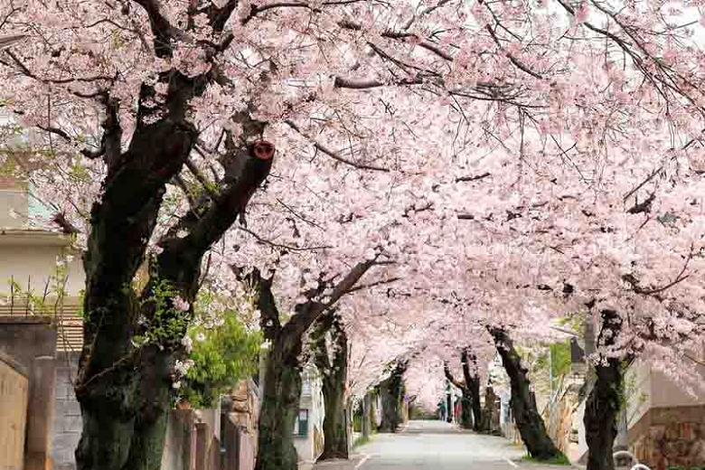

Regarded one of the most spectacular of flowering trees, the Yoshino cherry, Prunus x yedoensis, is highly celebrated for its thousands of showy, almond-scented blossoms coming out all at once along its bare branches in early spring and then quickly falling. Light pink in buds, the single flowers, 1.5 in. across (3-3.5 cm) sport 5 petals, first opening pale pink and fading to near white as they mature. Blooming for 2-3 weeks, they are held in clusters of 5-6 blossoms and give way to small, shiny, black fruits which are quickly devoured by birds. Native to Japan, the Yoshino cherry also has many other interesting assets such as a graceful branching pattern, glossy bark and dark green leaves which color well in the fall.

* The Yoshino cherry is a fast growing deciduous tree that can reach 40–50 ft. in height (12-15 m) and 25–40 ft. in spread at maturity (7-12 m) but is usually smaller. This tree is, however, relatively short-lived (15 to 20 years).
* It forms an upright, spreading to vase-shaped crown with ascending branches. Some cultivars feature an elegant weeping habit.
* Depending on Yoshino cherry cultivars, the showy flowers are white to pink, single or double, and slightly fragrant.
* As the flowers wane, the ovate, serrated, dark green leaves emerge and create a fresh summer canopy. They warm up to attractive shades of yellow, orange and red in the fall before shedding to the ground.
* The dark reddish-brown bark is marked by prominent lenticels which add winter interest.
* The Yoshino cherry is an excellent tree for lawns, along streets, near decks or patios.
* Full sun and partial shade are best for this tree (minimum of four hours of direct sunlight each day). Very versatile and adaptable to a wide range of soils, this Japanese flowering cherry tolerates heat and humidity, but not drought.
* The Yoshino cherry is prone to diseases and pests. Watch for caterpillars, leaf-mining moths, bullfinches, silver leaf, bacterial canker and blossom wilt.
* A hybrid between Prunus speciosa and Prunus subhirtella 'Rosea', The Yoshino cherry is one of the most popular flowering cherry trees grown in Japan. Along with the Kanzan cherry, this tree is responsible for the outstanding pink floral display each spring in Washington, D.C.

**Guide Information**

|  |  |
| --- | --- |
| **Hardiness** | 5 - 8 |
| **Heat Zones** | 3 - 8 |
| **Climate Zones** | 3, 4, 5, 6, 7, 14, 15, 16, 17, 18, 19, 20, 3A, 3B |
| **Plant Type** | Trees |
| **Plant Family** | Prunus - Flowering Trees |
| **Exposure** | Full Sun |
| **Season of Interest** | Spring Fall Winter |
| **Water Needs** | Average |
| **Maintenance** | Low |
| **Soil Type** | Chalk, Clay, Loam, Sand |
| **Soil pH** | Acid, Alkaline, Neutral |
| **Soil Drainage** | Moist but Well-Drained, Well-Drained |
| **Characteristics** | Fragrant, Showy |
| **Attracts** | Birds, Butterflies |
| **Landscaping Ideas** | [Beds and Borders](https://www.gardenia.net/plants/planting-place/beds-and-borders), [Patio and Containers](https://www.gardenia.net/plants/planting-place/patio_and_containers) |
| **Garden Styles** | [Informal and Cottage](https://www.gardenia.net/gardens/garden-styles/informal-and-cottage), [Japanese Garden](https://www.gardenia.net/gardens/garden-styles/japanese-garden), [Traditional Garden](https://www.gardenia.net/gardens/garden-styles/traditional-garden) |

*photop5 / paylessimages / 123RF Stock Photo*

While every effort has been made to describe these plants accurately, please keep in mind that height, bloom time, and color may differ in various climates. The description of these plants has been written based on numerous outside resources.

**Guide Information**

|  |  |
| --- | --- |
| **Hardiness** | 5 - 8 |
| **Heat Zones** | 3 - 8 |
| **Climate Zones** | 3, 4, 5, 6, 7, 14, 15, 16, 17, 18, 19, 20, 3A, 3B |
| **Plant Type** | Trees |
| **Plant Family** | Prunus - Flowering Trees |
| **Exposure** | Full Sun |
| **Season of Interest** | Spring Fall Winter |
| **Water Needs** | Average |
| **Maintenance** | Low |
| **Soil Type** | Chalk, Clay, Loam, Sand |
| **Soil pH** | Acid, Alkaline, Neutral |
| **Soil Drainage** | Moist but Well-Drained, Well-Drained |
| **Characteristics** | Fragrant, Showy |
| **Attracts** | Birds, Butterflies |
| **Landscaping Ideas** | [Beds and Borders](https://www.gardenia.net/plants/planting-place/beds-and-borders), [Patio and Containers](https://www.gardenia.net/plants/planting-place/patio_and_containers) |
| **Garden Styles** | [Informal and Cottage](https://www.gardenia.net/gardens/garden-styles/informal-and-cottage), [Japanese Garden](https://www.gardenia.net/gardens/garden-styles/japanese-garden), [Traditional Garden](https://www.gardenia.net/gardens/garden-styles/traditional-garden) |

[Not sure which Prunus - Flowering Trees to pick?  
Compare All Prunus - Flowering Trees](https://www.gardenia.net/compare-plants/prunus_--_flowering-trees) [Great Plant Combination   
Ideas with Prunus - Flowering Trees](https://www.gardenia.net/plant-combinations/plant-family/prunus_--_flowering-trees) [Guides with Prunus - Flowering Trees](https://www.gardenia.net/guides/plant-family/prunus_--_flowering-trees)

**Create the garden you’ve always wanted**

<https://www.gardenia.net/plant-variety/prunus-yedoensis-yoshino-cherry-tree>